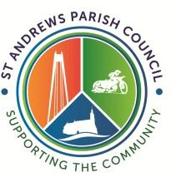
St Andrews Parish Council
Minutes of the Planning Committee Meeting
Held on Wednesday 25th March 2026 at 6pm
At Redhouse Community Centre, Swindon

Councillors Present: Kola Beyioku, Sue MacDonald and Vince Williams (Chairman)
Councillors Not Present: Paul Morris and Debbie Young
Officer Present: Mrs Rose – Deputy Clerk
Public Present: 1

APOLOGIES FOR ABSENCE
Apologies were received from Councillor Paul Morris

DECLARATION OF INTERESTS
No Declarations of Interest were received

MINUTES
RESOLVED to approve the minutes of the meeting held on 4th March 2026 as a record and signed by the Chairman.

CORRESPONDANCE
    - Councillors NOTED that we had received correspondence from a resident with concerns about another property being occupied for business use.
The planning committee will not formally comment unless Swindon Borough Council ask them to.
    - Swindon Borough Council Planning Department informed the parish that planning application S/25/1652 has been withdrawn.

PLANNING APPLICATIONS

    - S/HOU/26/0292
No objections

POST AGENDA APPLICATIONS
There were no post agenda applications.

Meeting ended: 18.10

Chairman Date

