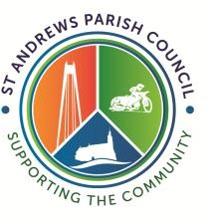
St Andrews Parish Council
Minutes of the Planning Committee Meeting
Held on Wednesday 15th April 2026 at 6:30pm
At Redhouse Community Centre, Swindon

Councillors Present: Paul Morris and Debbie Young
Councillors Not Present: Kola Beyioku, Vince Williams and Sue MacDonald
Officer Present: Louise Rose
Public Present: 0

APOLOGIES FOR ABSENCE
Cllrs Sue MacDonald and Vince Williams

The meeting was not quorate as only 2 St Andrews Parish Councillors were present.

The meeting closed at 6:45

Chairman |  |  | Date

