ST ANDREWS PARISH COUNCIL
Redhouse Community Centre, Frankel Avenue, Swindon SN25 2GY
Telephone: 07900 631 733 Email: standrewsparishcouncil@gmail.com

Parish Councillors are summoned to attend the Meeting of St Andrews Parish Council which will be held in the Parish Council Offices, Redhouse Community Centre, Frankel Avenue on Wednesday 10 January 2018 at 7.00pm
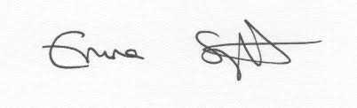

Miss Emma Sylvester
Parish Clerk to the Council
4 January 2018
Members of Public and Press are welcome.

AGENDA

APOLOGIES FOR ABSENCE
To receive and agree to accept apologies for absence.

DECLARATION OF INTERESTS
Members are invited to declare disclosable pecuniary interests and other interests in items on the agenda as required by the St Andrews Parish Council Code of Conduct for Members and by the Localism Act 2011.

MINUTES
To receive and approve the Minutes of the meeting of the Council held on 13th December 2017 (attached).

PUBLIC RECESS
Members of the public are invited to make representations to St Andrews Parish Council on any matters relating to the work of the Council. Public Bodies (Admission to Meetings) Act 1960

DRAFT BUDGET 2018/19
To discuss draft budget for 2018/19 (version 2 of spreadsheet attached)

